The Magic in the Box

What happens inside your computer when it runs a program? Let’s find out.

The program - the instructions for your processor (CPU) - first needs to tell the processor what to do. The processor writes any changes to memory and reads out the next instruction.

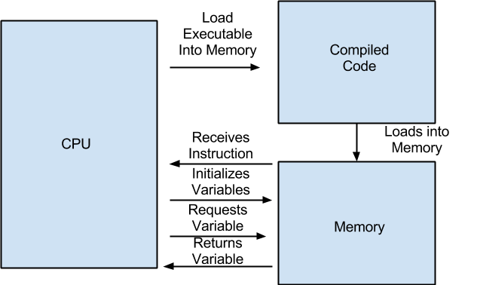

A brief introduction to your personal computer (PC). Hardware is the physical machine that make up a computer. Software is the group of programs that are used by a computer. The combination of hardware and software allows us to use our computers today. Input devices is anything that allows the user to “speak” to the computer (examples of input devices mouse and keyboards). On the contrary output devices is anything that allows the computer to “speak” to the user (an example of an output device is a monitor). The processor and the main memory are the the most vital part of the program and can be looked at as one. Once a network is established a group of computers connected in order to share information and other resources.

